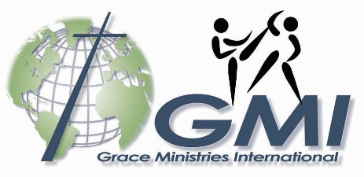
BreakThrough’s Latin America Invasion continues! After visiting Costa Rica in 2016, the BreakThrough martial arts team shared the gospel with over 3,500 people in Grace Ministries International’s newest field—Paraguay. They did this working alongside two of GMI’s missionary families who live and serve in the city of Ciudad del Este strategically located on Paraguay’s border with Brazil and Argentina. BreakThrough’s ministry and presence helped our missionaries’ relatively new church plant grow and strengthen, provided new contacts for the church in schools and the community, and infused some initial energy into the then fledgling youth ministry of the church. Our missionary team in Paraguay, along with the church they are planting, are now targeting yet another area of country to start another church. BreakThrough was a tool the Lord used effectively and mightily in Paraguay.
To read posts and articles about this team’s trips last year click on the following links:
Facebook
Grace Ministries Around the World
Truth Magazine (2017 Fall issue, page 10, “Expect a BreakThrough”)

Where are they going this year? Nicaragua is also one of GMI’s newest fields. This past year, the new church plant in the town of Nagarote—45 minutes north of the capital, Managua—moved from meeting in GMI missionaries Emiliano and Raquel Seravalli’s home to a property which they are developing. Their church, “Arraigados”—or “Rooted”—is growing as they share the gospel and disciple new leaders. With the new property and new leaders they are ready to use BreakThrough to reach more of Nagarote and to even help them generate contacts in surrounding towns which need churches that will share God’s grace through His Word.
GMI also works in the city of Matagalpa which is situated two and a half hours north of Managua in the interior of the country. The church planting and leadership training efforts in Matagalpa are led by GMI missionaries Brett and Debby Chapman and Jeff and Sally Roth. Matagalpa and the surrounding area are home to a few hundred thousand people. The BreakThrough team will be used to evangelize, draw people into various Bible studies, and theological training programs which will all serve the ultimate goal of planting a church in this area.
BreakThrough’s mission is simple. This team was formed and exists to effectively and responsibly share the Gospel of Jesus Christ while supporting missionaries in their local field through the use of dynamic, Christ-centered martial arts. This year, as in the two previous years, they will conduct outreach demonstrations and hold martial arts classes to reach people for Jesus Christ as they support the work of our three missionary families in Nicaragua this August.
You are receiving this letter because a member of BreakThrough is asking you to join the effort. This is not your typical mission trip and very few could do what this dedicate group is doing. Though, thankfully, some funds have already been pledged to help the team serve in Nicaragua, each team member must raise $1,650 for airfare, food, lodging, and supplies by July 1. The $850 for airfare must be raised by May 1 so they can purchase tickets. You can make a tax-deductible gift to support a member of this team by clicking HERE to give online through Grace Ministries International, selecting “Other” from the account dropdown menu, and writing “BreakThrough 2018” along with the name of the team member you are supporting in the comments box. Another way is by mailing a check along with a post-it note designating who the gift is for to Grace Ministries International, PO Box 9405, Grand Rapids, MI 49509.
It is my pleasure to work with this team and facilitate their ministry in any way possible. As individuals and as a team they continue to grow as they use their talents unto the Lord.

Pressing towards the goal,
Jeremy Clark
Executive Director
Grace Ministries International

